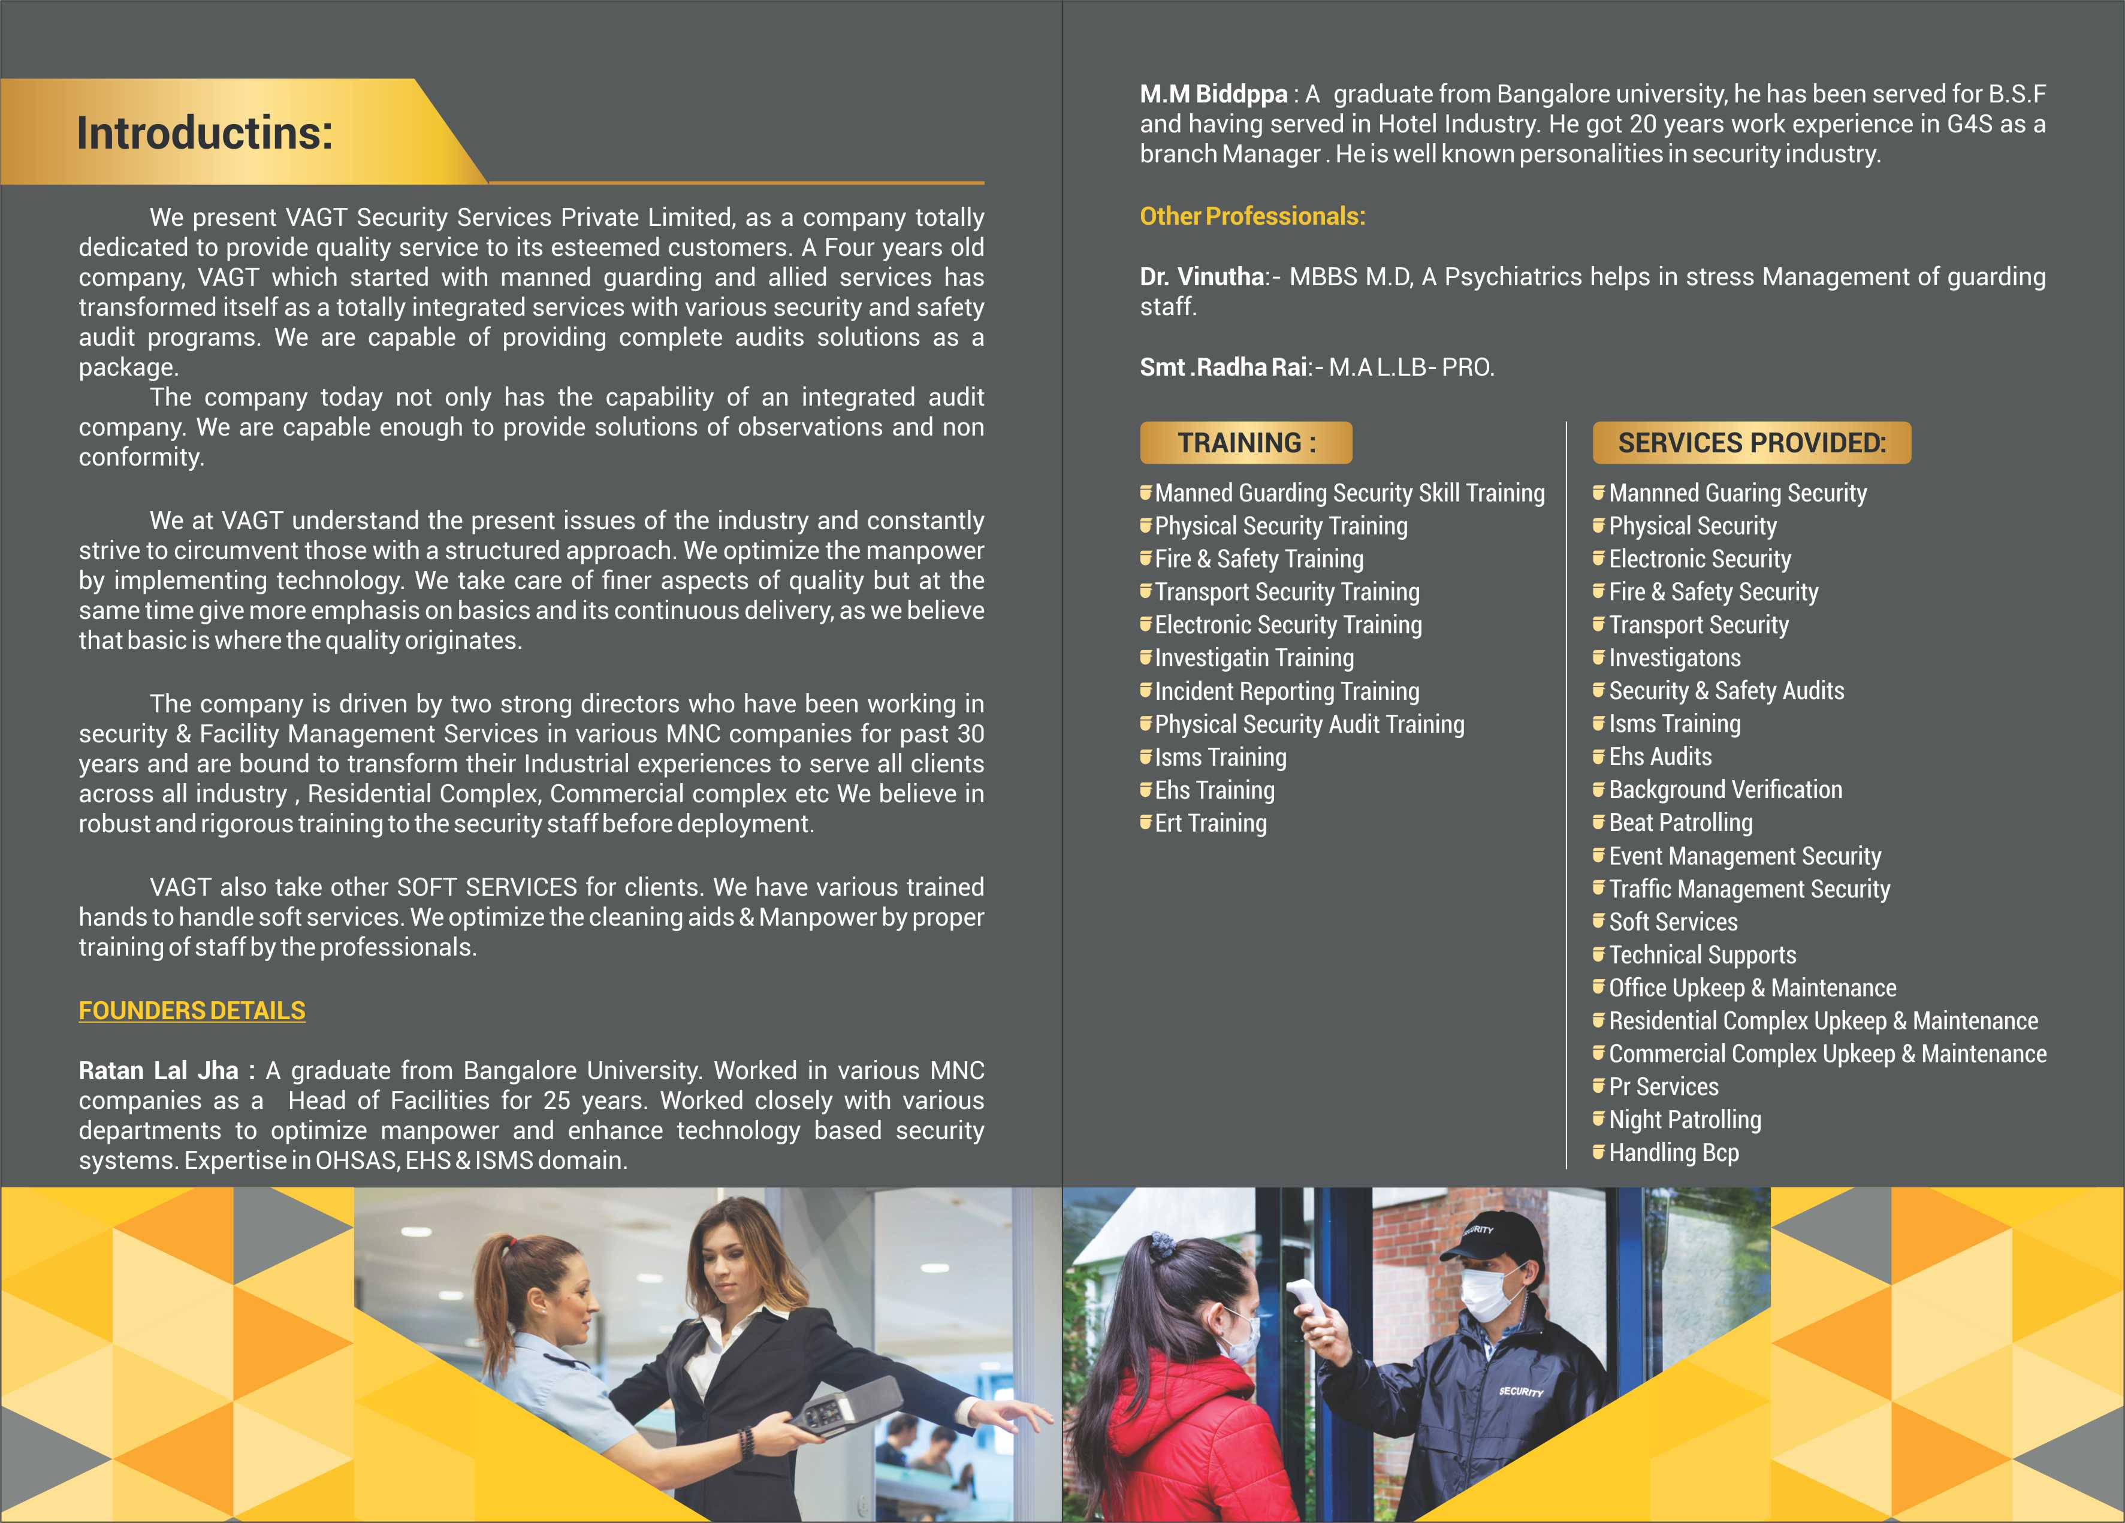
Client Centric
We always start from your
perspective, identifying the risks your business faces and how we can protect it.

People Focussed
VAGT is a responsible employer, and we believe we have the best and most engaged employees in the industry.

Data Driven
The ongoing digitisation of VAGT operations enables us to offer your business better analysis, risk assessments and solutions for preventive security measures

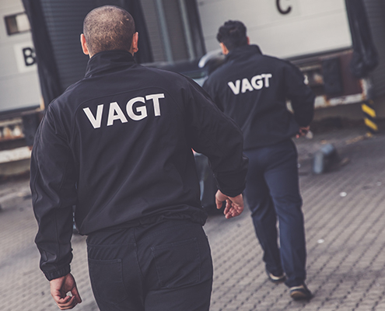
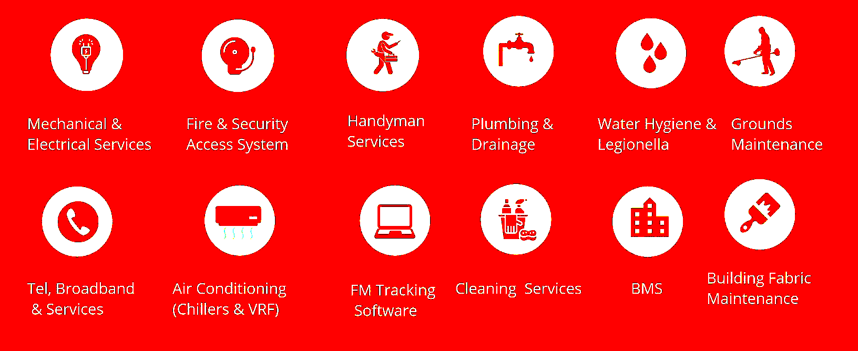
Comprehensive Services at a Glance

